**Name:** Nagaraju **Emp.ID:** 213295

# Assignment: LINUX SHELL SCRIPTING

## Scripts:

### When you run the script, display all file information from current working directory

#### Script:

*#!/bin/bash*

*ls -la | more*

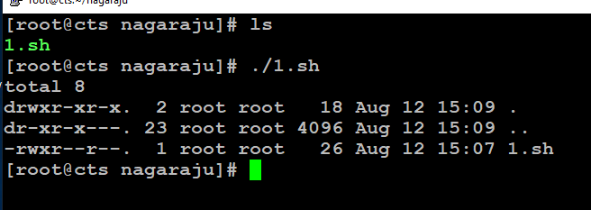

Figure 1: Script1 Execution

### Read a value from user Create a pattern as mentioned below

Pattern

1

1 2

1 2 3

1 2 3 4

#### Script:

*#!/bin/bash*

*for (( i=1; i<=4; i++ ))*

*do*

*for (( j=1; j<=i; j++ ))*

*do*

*echo -n "$j "*

*done*

*echo ""*

*done*

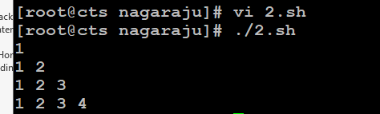

Figure 2: Script2 Executed

### Read a value from user Create a pattern as mentioned below

Pattern

1

2 3

4 5 6

7 8 9 10

#### Script:

*#!/bin/bash*

*num=1*

*echo "Enter number rows: `$rows`"*

*read rows*

*for (( i=1; i<=rows; i++ ))*

*do*

*for (( j=1; j<=i; j++ ))*

*do*

*echo -n "$num "*

*num=$((num + 1 ))*

*done*

*echo*

*done*

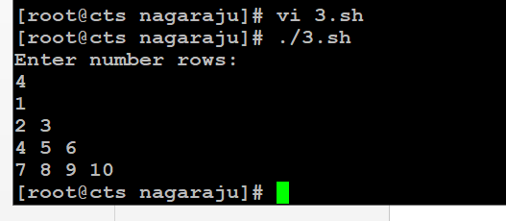

Figure 3: Script3 Executed

### Provide a menu to user to select ssh or scp. Based on user selection ask for user name and ipaddress. For scp ask user for direction of copy remote to local local to remote. copy file to destination home directory with same source file name. Ask for source/destination file location. If no destination location is provided. If user gives destination along with filename, keep that as destination filename.If user provides only destination location (no file name), keep as source file name

### Note: User should know the password for remote user.

### Ask user to enter two numbers, User can enter real numbers also, Use bc command and piping to do

#### Script:

*#!/bin/bash*

*echo "Enter two numbers a and b: "*

*read a b*

*echo $a + $b | bc*

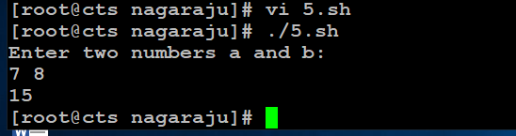

Figure 4: Script5 Executed

### User must provide two numbers and operator through command-line Based on input do the operation and show the output. Use case to handle multiple operations Use expr or bc commands.

#### Script:

#!/bin/bash

echo "sum of $1 and $2 is:"

echo $1 + $2 | bc

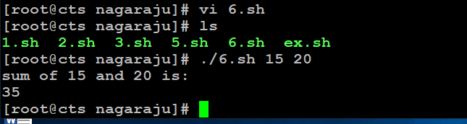

Figure : Output of the 6th shell script

### Using command-line pass n arguments. Compare all these arguments and print the largest Value. Print error in-case no arguments. Number of arguments can vary every time.

#### Script:

#!/bin/bash

echo "Enter the size of numbers(N)"

read N

i=1

max=0

echo "Enter the numbers"

while [ $i -le $N ]

do

read num

if [ $i -eq 1 ]

then

max=$num

else

if [ $num -gt $max ]

then

max=$num

fi

fi

i=$((i + 1))

done

echo "largest value is" $max

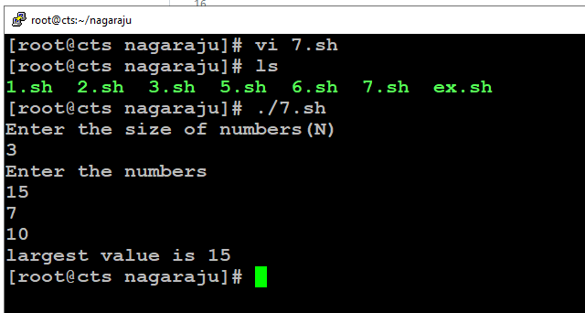

Figure : Output of the 7th shell script

### Read an multi-digit number from user and reverse the number. It’s not just printing in reverse order, You have to extract each digit and convert to reverse. When ‘0’ comes as last digit, discard while reversing.

#### Script:

*#!/bin/bash*

*echo "Enter a number"*

*read a*

*sd=0*

*rev=0*

*while [ $a -gt 0 ]*

*do*

*sd=$(( $a % 10 ))*

*rev=$(( $rev * 10 + $sd ))*

*a=$(( $a / 10))*

*done*

*echo "reverse order of entered number is" $rev*

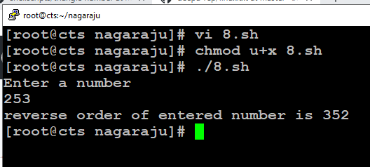

Figure : Output of the 8th shell script

### Pass a filename through command-line. Delete all the empty lines from that file and save it back.

#### Script:

*#!/bin/bash*

*echo "Enter a file name and extension"*

*read $a*

*sed '/^$/d' raju.txt*

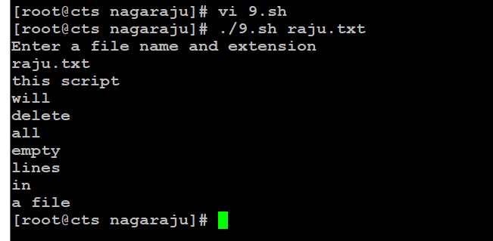

Figure : Output of the 9th shell script

### Read a string from user, must end with an operator symbol. Number can be any length but must end with an operator character Always do left to right operations. If 8312 – passed do 8-3-1-2 = 2

#### Script:

#!/bin/bash

echo "Enter a number or string"

read a

i=$((${#a}-1))

echo ${a:$i:1}

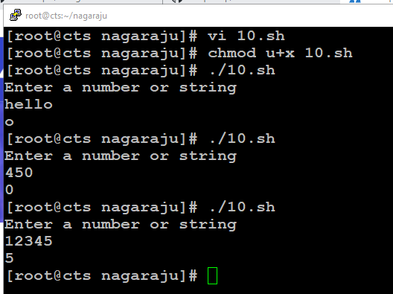

Figure : Output of the 10th shell script

### Remember n is not number of elements to print. It’s the boundary of elements to print.

#### Script:

*#! /bin/bash*

*echo "Enter the value of n"*

*read n*

*a=0*

*b=1*

*count=2*

*echo "Fibonacci series:"*

*echo $a*

*echo $b*

*while [ $count -le $n ]*

*do*

*fib=`expr $a + $b`*

*a=$b*

*b=$fib*

*echo $fib*

*count=`expr $count + 1`*

*done*

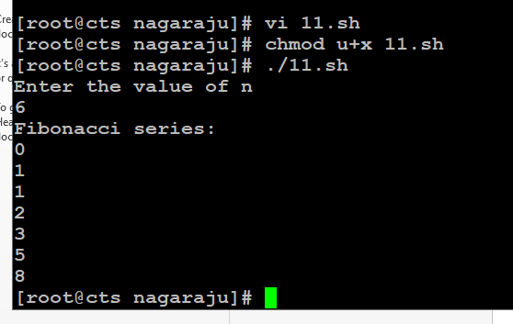

Figure : Output of the 11th shell script

### Pass some names or strings from command-line. Print all the string lengths one-by-one. Number of argument may vary.

#### Script:

*#!/bin/bash*

*echo " Enter 5 numbers or strings"*

*read a b c d e*

*n=${#a}*

*echo "string length is " $n*

*m=${#b}*

*echo "string length is " $m*

*o=${#c}*

*echo "string length is " $o*

*p=${#d}*

*echo "string length is " $p*

*q=${#e}*

*echo "string length is " $q*

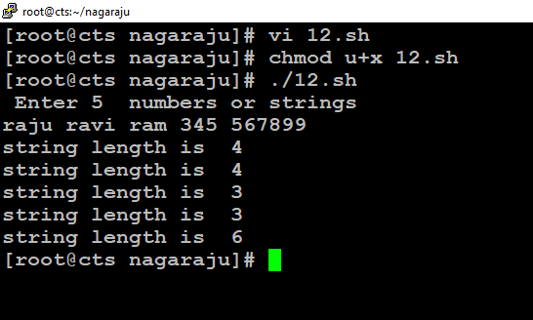

Figure : Output of the 12th shell script

### To print a black box echo -e -n “\\\\e[40m” ” “

### To print a white box echo -e -n “\\\\e[47m” ” “

### Call the commands in a loop.

### After 8 columns make to normal color.

### To make it normal echo -e -n “\\\\e[0m” ” “

#### Script:

*#!/bin/bash*

*echo "Chess Board"*

*for (( i=1; i<=8; i++))*

*do*

*for (( j=1; j<=8; j++))*

*do*

*total=$(($i+$j))*

*temp=$(($total%2))*

*# for alternative blocks*

*if [ $temp -eq 0 ]*

*then*

*echo -e -n "\033[47m" " " #white*

*else*

*echo -e -n "\033[40m" " " #black*

*fi*

*done*

*echo -e -n "\033[0m" " "*

*echo ' '*

*done*

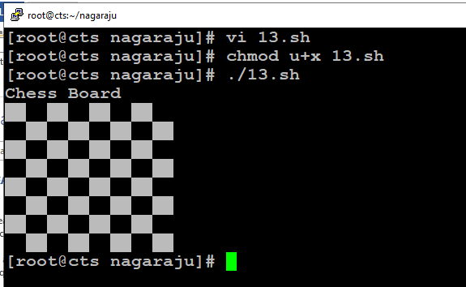

Figure : Output of the 13th shell script

### Pass numbers through command-line arguments. Provide a menu for user to choose ascending or descending. Show sorted array according to user choice.

#### Script:

*#!/bin/bash*

*echo "Enter 5 number and ordered or unordered array"*

*read a b c d e f g*

*arr=($a $b $c $d $e)*

*echo "Array in original order"*

*echo ${arr[*]}*

*for ((i = 0; i<5; i++))*

*do*

*for((j = 0; j<5-i-1; j++))*

*do*

*if [ ${arr[j]} -gt ${arr[$((j+1))]} ]*

*then*

*# swap*

*temp=${arr[j]}*

*arr[$j]=${arr[$((j+1))]}*

*arr[$((j+1))]=$temp*

*fi*

*done*

*done*

*echo "Array in ascending order :"*

*echo ${arr[*]}*

*echo "Array in reverse order :"*

*echo ${arr[*]} | rev*

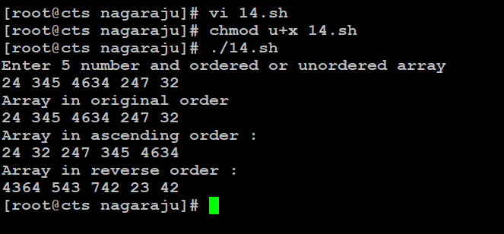

Figure : Output of the 14th shell script

### Provide a menu for user about what information he wants to check. Using switch case display output for selected option.

#### Script:

*#!/bin/bash*

*nouser=`who | wc -l`*

*echo -e "User name: $USER (Login name: $LOGNAME)" >> /tmp/info.tmp.01.$$$*

*echo -e "Current Shell: $SHELL" >> /tmp/info.tmp.01.$$$*

*echo -e "Home Directory: $HOME" >> /tmp/info.tmp.01.$$$*

*echo -e "Your O/s Type: $OSTYPE" >> /tmp/info.tmp.01.$$$*

*echo -e "PATH: $PATH" >> /tmp/info.tmp.01.$$$*

*echo -e "Current directory: `pwd`" >> /tmp/info.tmp.01.$$$*

*echo -e "Currently Logged: $nouser user(s)" >> /tmp/info.tmp.01.$$$*

*if [ -f /etc/redhat-release ]*

*then*

*echo -e "OS: `cat /etc/redhat-release`" >> /tmp/info.tmp.01.$$$*

*fi*

*if [ -f /etc/shells ]*

*then*

*echo -e "Available Shells: " >> /tmp/info.tmp.01.$$$*

*echo -e "`cat /etc/shells`" >> /tmp/info.tmp.01.$$$*

*fi*

*if [ -f /etc/sysconfig/mouse ]*

*then*

*echo -e "--------------------------------------------------------------------" >> /tmp/info.tmp.01.$$$*

*echo -e "Computer Mouse Information: " >> /tmp/info.tmp.01.$$$*

*echo -e "--------------------------------------------------------------------" >> /tmp/info.tmp.01.$$$*

*echo -e "`cat /etc/sysconfig/mouse`" >> /tmp/info.tmp.01.$$$*

*fi*

*echo -e "--------------------------------------------------------------------" >> /tmp/info.tmp.01.$$$*

*echo -e "Computer CPU Information:" >> /tmp/info.tmp.01.$$$*

*echo -e "--------------------------------------------------------------------" >> /tmp/info.tmp.01.$$$*

*cat /proc/cpuinfo >> /tmp/info.tmp.01.$$$*

*echo -e "--------------------------------------------------------------------" >> /tmp/info.tmp.01.$$$*

*echo -e "Computer Memory Information:" >> /tmp/info.tmp.01.$$$*

*echo -e "--------------------------------------------------------------------" >> /tmp/info.tmp.01.$$$*

*cat /proc/meminfo >> /tmp/info.tmp.01.$$$*

*if [ -d /proc/ide/hda ]*

*then*

*echo -e "--------------------------------------------------------------------" >> /tmp/info.tmp.01.$$$*

*echo -e "Hard disk information:" >> /tmp/info.tmp.01.$$$*

*echo -e "--------------------------------------------------------------------" >> /tmp/info.tmp.01.$$$*

*echo -e "Model: `cat /proc/ide/hda/model` " >> /tmp/info.tmp.01.$$$*

*echo -e "Driver: `cat /proc/ide/hda/driver` " >> /tmp/info.tmp.01.$$$*

*echo -e "Cache size: `cat /proc/ide/hda/cache` " >> /tmp/info.tmp.01.$$$*

*fi*

*echo -e "--------------------------------------------------------------------" >> /tmp/info.tmp.01.$$$*

*echo -e "File System (Mount):" >> /tmp/info.tmp.01.$$$*

*echo -e "--------------------------------------------------------------------" >> /tmp/info.tmp.01.$$$*

*cat /proc/mounts >> /tmp/info.tmp.01.$$$*

*if which dialog > /dev/null*

*then*

*dialog --backtitle "Linux Software Diagnostics (LSD) Shell Script Ver.1.0" --title "Press Up/Down Keys to move" --textbox /tmp/info.tmp.01.$$$ 21 70*

*else*

*cat /tmp/info.tmp.01.$$$ |more*

*fi*

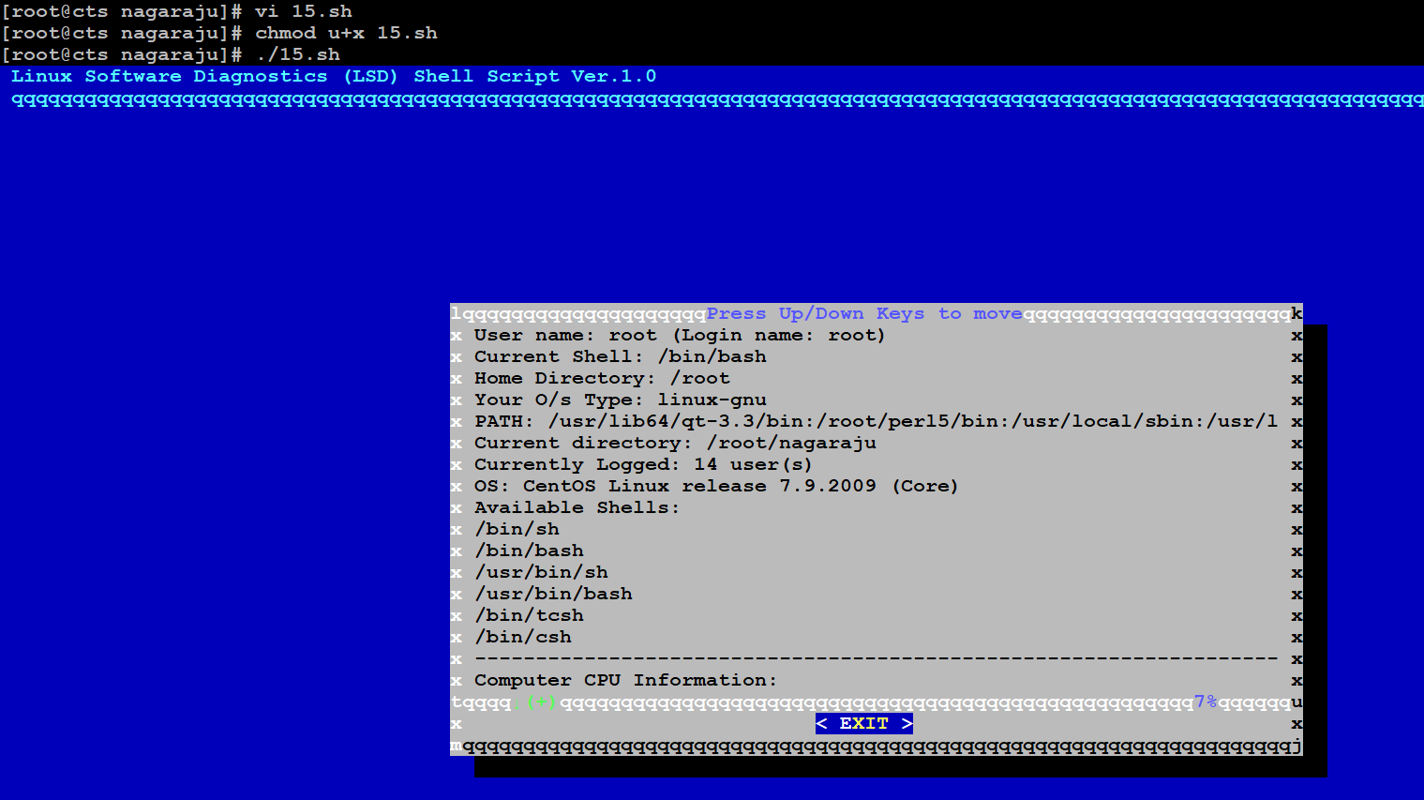

Figure : Output of the 15th shell script

### Remember n is not nth number of series. It’s the greatest element to print.

#### Script:

*#! /bin/bash*

*echo "Enter the value of n"*

*read n*

*a=0*

*b=1*

*count=2*

*echo "Fibonacci series:"*

*echo $a*

*echo $b*

*while [ $count -le $n ]*

*do*

*fib=`expr $a + $b`*

*a=$b*

*b=$fib*

*echo $fib*

*count=`expr $count + 1`*

*done*

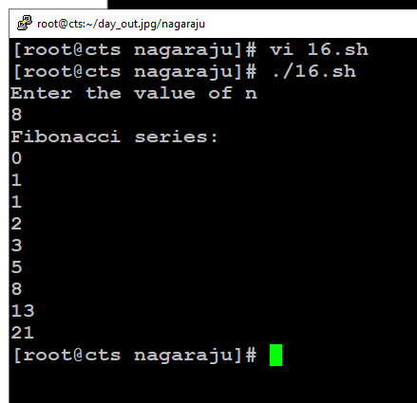

Figure : Output of the 16th shell script

### Rename all files from current directory to lowercase letters. Rename all directories from current directories to uppercase. Digits and other symbols should remain same.

#### Script:

*#!/bin/bash*

*if [ -z $1 ];then*

*echo "Usage :$(basename $0) parent-directory"*

*exit 1*

*fi*

*#process all subdirectories and files in parent directory*

*all="$(find $1 -depth)"*

*for name in ${all}; do*

*#set new name in lower case for files and directories*

*new_name="$(dirname "${name}")/$(basename "${name}" | tr '[A-Z]' '[a-z]')"*

*if [ "${name}" != "${new_name}" ]; then*

*[ ! -e "${new_name}" ] && mv -T "${name}" "${new_name}"; echo "${name} was renamed to ${new_name}" || echo "${name} wasn't renamed!"*

*fi*

*done*

*echo*

*echo*

*#list directories and file new names in lowercase*

*echo "Directories and files with new names in lowercase letters"*

*find $(echo $1 | tr 'A-Z' 'a-z') -depth*

*exit 0*

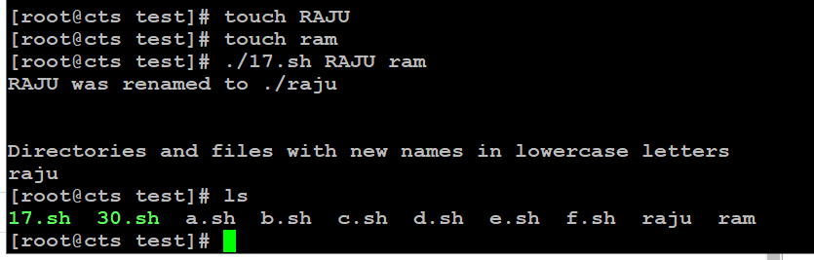

Figure : Output of the 17th shell script

### After executing this script your current directory will be renamed to given name. Pass new name through command-line.

#### Script:

*#!/bin/bash*

*echo "Enter the file name you want to rename"*

*read a*

*echo "Enter the new file name to the file"*

*read b*

*mv $a $b*

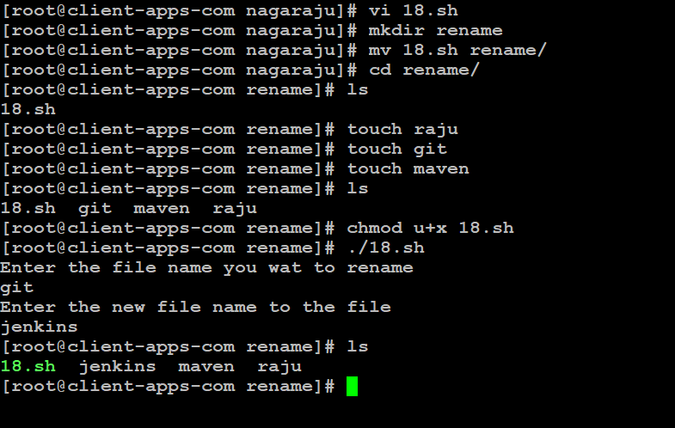

Figure : Output of the 18th shell script

### Aim of this project is to rename all files in one directory with a common name and indexing. Usually when we takes pics in camera or mobile default names are like DSN001.jpg, DSN002.jpg. These files need to be renamed by user given prefix name. Prefix name pass through command-line argument.

*#!/bin/bash*

*echo "Enter the target directory "*

*read target_dir*

*cd $target_dir*

*echo "Enter the file extension to search without a dot"*

*read old_ext*

*echo "Enter the new file extension to rename to without a dot"*

*read new_ext*

*echo "$target_dir, $old_ext, $new_ext"*

*for file in *.$old_ext*

*do*

*mv -v "$file" "${file%.$old_ext}.$new_ext"*

*done;*

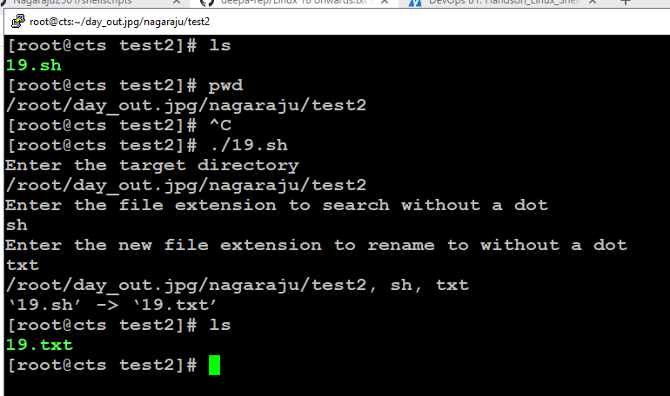

Figure : Output of the 19th shell script

### Pass three command-line arguments

### 1- Starting line number

### 2-number of lines and filename

### Script will print n lines from given starting line

### 21)

### The script should run as soon as you log-on to system

### Print greetings based on time as follows.

### “Good morning” (5 AM – 12 PM)

### “Good noon” (12 PM – 1 PM)

### “Good afternoon” (2 PM – 5 PM)

### “Good evening” (5PM – 9 PM)

### “Good night” (9 PM – 5 AM)

#### Script:

*#!/bin/bash*

*hour=`date +%c | tr -s " " | cut -d " " -f4 | cut -d ":" -f1`*

*day=`date +%A`*

*mon=`date +%B`*

*dte=`date +%d`*

*year=`date +%Y`*

*tf=`date +%r`*

*if [ $hour -ge 5 -a $hour -lt 12 ]*

*then*

*echo -e "Good morning `whoami`, Have nice day!\nThis is $day $dte in $mon of $year ($tf)"*

*elif [ $hour -ge 12 -a $hour -le 13 ]*

*then*

*echo -e "Good noon `whoami`, Have nice day!\nThis is $day $dte in $mon of $year ($tf)"*

*elif [ $hour -ge 14 -a $hour -lt 17 ]*

*then*

*echo -e "Good afternoon `whoami`, Have nice day!\nThis is $day $dte in $mon of $year ($tf)"*

*elif [ $hour -ge 17 -a $hour -lt 21 ]*

*then*

*echo -e "Good evening `whoami`, Have nice day!\nThis is $day $dte in $mon of $year ($tf)"*

*elif [ $hour -ge 21 -o $hour -lt 5 ]*

*then*

*echo -e "Good night `whoami`, Have nice day!\nThis is $day $dte in $mon of $year ($tf)"*

*fi*

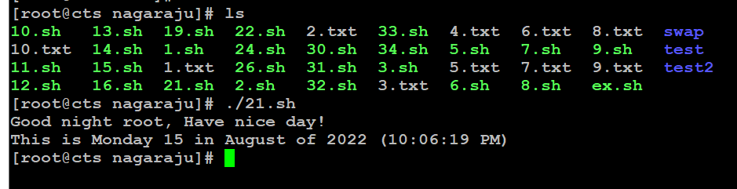

Figure : Output of the 21st shell script

### Provide a filename through command-line. Ask user for conversion Lower to Upper / Upper to Lower.

#### Script:

*#!/bin/bash*

*getFile(){*

*# Reading txtFileName to convert it's content*

*echo -n "Enter File Name:"*

*read txtFileName*

*# Checking if file exist*

*if [ ! -f $txtFileName ]; then*

*echo "File Name $txtFileName does not exists."*

*exit 1*

*fi*

*}*

*clear*

*echo "1. Uppercase to Lowercase "*

*echo "2. Lowercase to Uppercase"*

*echo "3. Exit"*

*echo -n "Enter your Choice(1-3):"*

*read Ch*

*case "$Ch" in*

*1)*

*getFile*

*# Converting to lower case if user chose 1*

*echo "Converting Upper-case to Lower-Case "*

*tr '[A-Z]' '[a-z]' <$txtFileName*

*;;*

*2)*

*getFile*

*# Converting to upper case if user chose 2*

*echo "Converting Lower-Case to Upper-Case "*

*tr '[a-z]' '[A-Z]' <$txtFileName*

*;;*

*\*) # exiting for all other cases*

*echo "Exiting..."*

*exit*

*;;*

*esac*

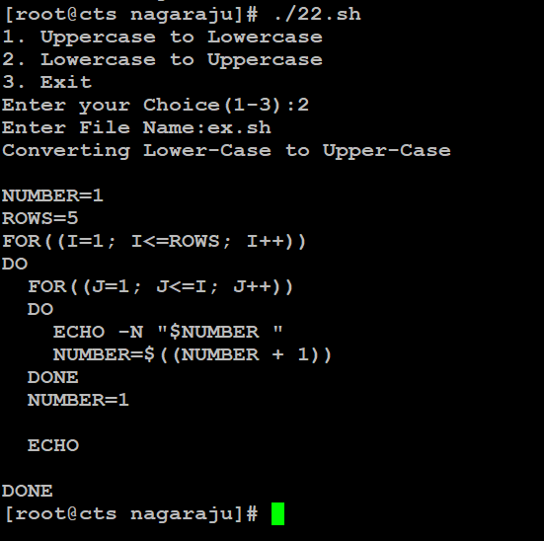

Figure : Output of the 22nd shell script

### Fetch user-names from the first field in /etc/passwd file. Print longest and shortest name.

#### Script:

*#!/bin/bash*

*echo "the longest and shortest usernames on the system are: "*

*cat /etc/passwd > tempFile*

*sed '/^#/d' tempFile > tempFile2*

*#get the user name list and the Total username count*

*totalUserNames=`cat tempFile2 | cut -d":" -f1`*

*totalUserCount=`cat tempFile2 | cut -d":" -f1 | wc -l`*

*longlettercount=0*

*shortlettercount=$((`echo $totalUserNames | cut -d" " -f1 | wc -m`-1))*

*#to get the longest and shortest usernames*

*for (( i=1; i<=$totalUserCount; i++ ))*

*do*

*username=`echo $totalUserNames | cut -d" " -f$i`*

*namecount=$((`echo $totalUserNames | cut -d" " -f$i | wc -m`-1))*

*if [ $namecount -ge $longlettercount ]*

*then*

*#if the namecount is greater than previously saved longlettercount, update the longest word to be the current username and longlettercount to current namecount*

*longestword=$username*

*longlettercount=$namecount*

*elif [ $namecount -le $shortlettercount ]*

*then*

*#if the namecount is smaller than previously saved shortlettercount, update the shortestword to be the current username and shortlettercount to current namecount*

*shortestword=$username*

*shortlettercount=$namecount*

*fi*

*done*

*echo " shortest username: $shortestword "*

*echo " longest username: $longestword "*

*#clean the tempFiles*

*rm -f tempFile*

*rm -f tempFile2*

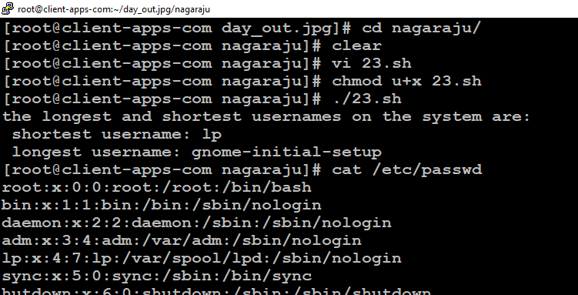

Figure : Output of the 23rd shell script

### Find and delete all .swp files (Temperory vi files). If command-line directories are passed delete only from that directories. If no arguments passed delete from entire ~/ directory, If no file present show a message.

#### Script:

*#!/bin/bash*

*if [ $# -eq 1 ]*

*then*

*if [ -d $1 ]*

*then*

*swps=(`find $1 -name "*.swp" -type f`)*

*if [ ${#swps[@]} -ne 0 ]*

*then*

*find $1 -name "*.swp" -type f -delete*

*else*

*echo "No swp files found in test_swp."*

*fi*

*else*

*echo "Error : '$1' no such a file or directory"*

*fi*

*else*

*swps=(`find ~ -name "*.swp" -type f`)*

*if [ ${#swps[@]} -ne 0 ]*

*then*

*echo "swap file found :"*

*find ~ -name "*.swp" -type f*

*fi*

*fi*

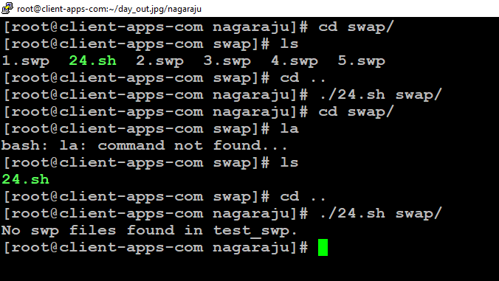

Figure : Output of the 24th shell script

### 25) Every time a new password must create. Password must contains a alpha-numeric and special characters.

#### Script:

*#!/bin/bash*

*#random 8-character passwords including alpha numeric characters*

*cat /dev/urandom | LC_ALL=C tr -cd 'a-zA-Z0-9' | fold -w 8 | head -n 1*

*#advantage of being portable between OS X, Redhat, and Ubuntu.*

*#perl -pe 'tr/A-Za-z0-9//dc;' < /dev/urandom | head -c 8; echo*

*#In Ubuntu*

*#cat /dev/urandom | tr -cd 'a-zA-Z0-9' | fold -w 8 | head -n 1*

*#random 8-character passwords include everything {alpha-numeric, special }*

*#cat /dev/urandom | strings | head -n 1*

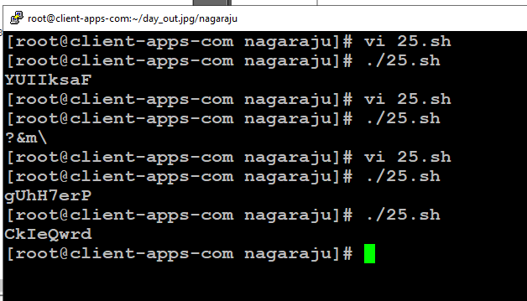

Figure : Output of the 25th shell script

### 26) This script will work like a ls command. Don’t use ls command. Pass any number of directories through command line. If no arguments passed, list current directory

#### Script:

*if [ $# -lt 1 ]*

*then*

*echo "Error: Invalid input. Enter a minimum of 1 arg (directory)]"*

*exit 1*

*fi*

*myDirectoryArray=($@)*

*#check for valid directory*

*for (( i=0; i < ${#myDirectoryArray[@]}; i++ ))*

*do*

*if [ ! -d ${myDirectoryArray[$i]} ]*

*then*

*echo "${myDirectoryArray[$i]} is not a directory"*

*else*

*#if valid, change to that directory and list*

*echo "${myDirectoryArray[$i]}: "*

*cd ${myDirectoryArray[$i]};ls*

*fi*

*done*

: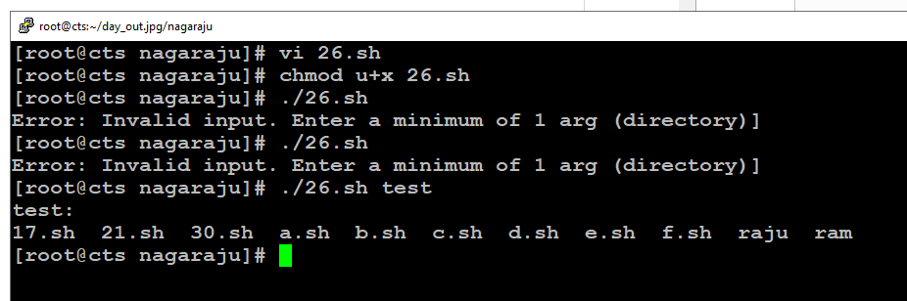

Figure : Output of the 26th shell script

### 27) The final output becomes the input again to the command line. Be alert, remember to stop this command before it fills your hard disk. Look at the documentation for the tail command.

### 28) We pass command-line arguments to script. Script call function with same arguments. Regardless of how many arguments are passed. You are allowed to echo only the first positional argument (echo $1).

#### Script:

*#!/bin/bash*

*if [ $# -lt 1 ]*

*then*

*echo "Error: Invalid argument count"*

*echo "Usuage: arg1 arg2 arg3"*

*exit 1*

*fi*

*arrayOfArg=($@)*

*printArguments()*

*{*

*#if there is only one value print and return*

*if [ $# -eq 1 ]*

*then*

*echo $1*

*return*

*fi*

*#Get the argument list into temp array and print first arg*

*temparray=($@)*

*echo $1*

*#set a recurArray to empty, else it will not be cleared on recurrsive call*

*recurArray=()*

*#get the shifted values to print the remaining arg excluding first*

*for (( i=0; i<${#temparray[@]}; i++ ))*

*do*

*recurArray+=(${temparray[$(($i+1))]})*

*done*

*#recursively call for teh remaining arguments*

*printArguments ${recurArray[@]}*

*}*

*printArguments ${arrayOfArg[@]}*

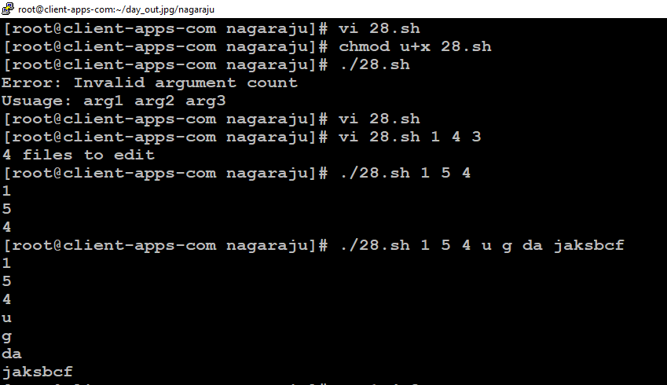

Figure : Output of the 28th shell script

### 29) Check that given file-system is mounted or not If its mounted, print free-space available in it. Other-wise print error message.

*#!/bin/bash*

*echo "Enter a name of the filesystem"*

*read a*

*echo "checking..., the file system is mounted or not"*

*findmnt $a*

*echo "free space in the mounted filesystem is:"*

*findmnt --df*

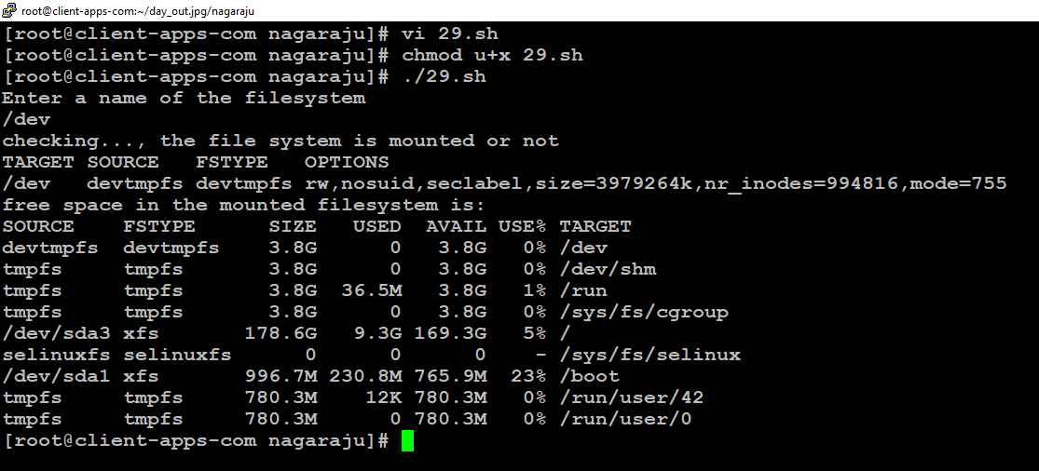

Figure : Output of the 29th shell script

### 30) Remove all permissions for groups and others. Provide directory name through command-line. After running script all files in the given directory, Only should have all the permissions. But remember don’t add any permission to user only change to others and groups.

#### Script:

#### 

*#!/bin/bash*

*if [ $# -eq 1 ]*

*then*

*echo "Before locking"*

*ls -l $1/*

*chmod -R go-rwx $1/*

*echo "After locking"*

*ls -l $1/*

*else*

*echo "Error : Please pass the directory in command line"*

fi

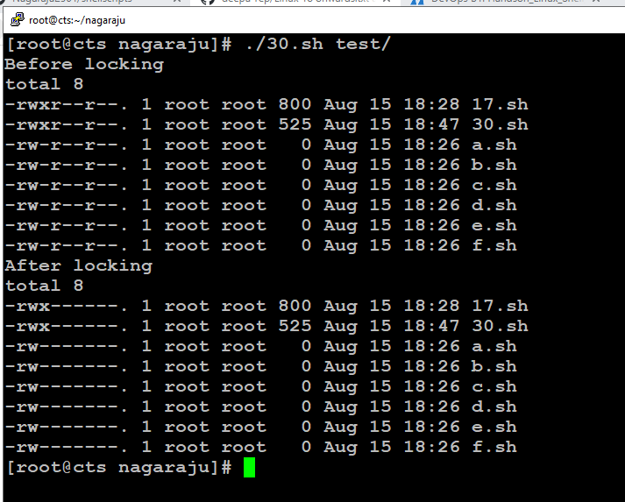

Figure : Output of the 30th shell script

### 31) When you run the script show all file-system present in system. Then print file-systems that have only 10% memory remaining.

#### Script:

*#!/bin/bash*

*filesys=(`df | tr -s " " | cut -d " " -f1`)*

*for j in ${filesys[@]}*

*do*

*echo "$j"*

*done*

*useper=(`df | tr -s " " | cut -d " " -f5 | cut -d "%" -f1`)*

*for i in `seq $((${#useper[@]}-1))`*

*do*

*if [ ${useper[i]} -ge 90 ]*

*then*

*echo "Filesystem ${filesys[i]} have less than 10% free space"*

*fi*

*done*

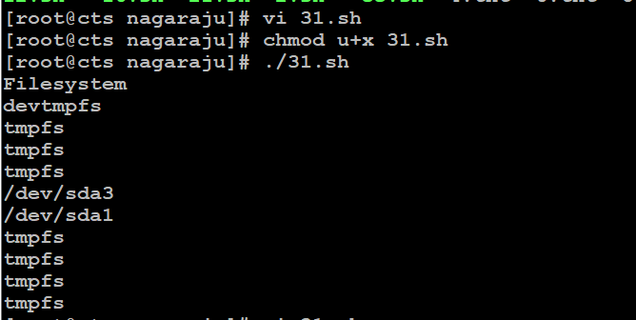

Figure : Output of the 31st shell script

### 32) Fetch user-ids from the in /etc/passwd file. Display only usernames between the range. User can change the range using command-line arguments. Default is 500 – 100000

#### Script:

*#!/bin/bash*

*usrid=(`cut -d ":" -f3 /etc/passwd`)*

*if [ $# -gt 0 ]*

*then*

*if [ $# -eq 1 ]*

*then*

*echo "Error : Please pass 2 arguments through CL.*

*Usage : ./30_user_ids.sh 100 200"*

*elif [ $1 -gt $2 ]*

*then*

*echo "Error : Invalid range. Please enter the valid range through CL."*

*else*

*count=0*

*for i in ${usrid[@]}*

*do*

*if [ $i -ge $1 -a $i -le $2 ]*

*then*

*let count=$count+1*

*fi*

*done*

*echo "Total count of user ID between $1 to $2 is : $count"*

*fi*

*else*

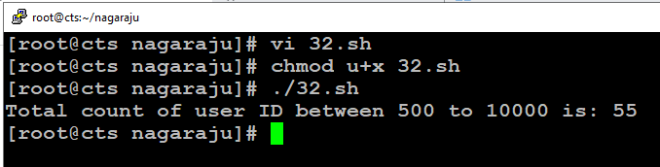

Figure : Output of the 32nd shell script

### 33)

### Fetch each directories from PATH variable.

### Use -x option if if condition to check executable permission.

### Print directory and number of executable files one-by-one.

### Print the total number of executable files at last.

### Count only files have executable permission.

### Verify path is present every-time.

*#!/bin/bash*

*arr=(`printenv PATH | tr ":" " "`)*

*total=0*

*for i in ${arr[@]}*

*do*

*if [ -d $i ]*

*then*

*cd $i*

*count=0*

*for j in `ls`*

*do*

*if [ -f $j -a -x $j ] #*

*then*

*let count=$count+1*

*fi*

*done*

*echo -e "Current dir: $i\nCurrent count: $count"*

*let total=$total+$count*

*fi*

*done*

*echo "Total - $total"*

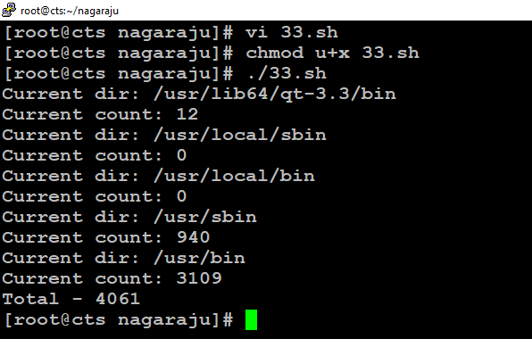

Figure : Output of the 33rd shell script

### 34) Fetch user-names from the first field in /etc/passwd file. Search given name in the list.

#### Script:

*#!/bin/bash*

*echo "Please input the user name"*

*read name*

*cat /etc/passwd | awk -F":" -v name="$name" '{*

*if ($1==name)*

*{*

*print $1," ",$3," ",$4*

*flag=1*

*}*

*}*

*END{*

*if (flag==0)*

*print "not a valid account"*

*}'*

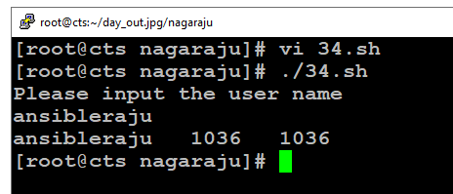

Figure : Output of the 34th shell script

### 35) Provede a .c file to this script through commandline. Randomly delete 20% lines from the file. Where ever you deleted replace a string